Ex.No : 13 Practice with Web Services
Date : 19-09-2025

Aim:
To practice with Web Services such REST and SOAP.
Procedure:
REST
- REST API stands for Representational State Transfer API.
- It is a type of API (Application Programming Interface) that allows communication between different systems over the internet. REST APIs work by sending requests and receiving responses, typically in JSON format, between the client and server.
- A request is sent from the client to the server via a web URL, using one of the HTTP methods.
- The server then responds with the requested resource, which could be HTML, XML, Image, or JSON, with JSON being the most commonly used format for modern web services.
- These methods map to CRUD operations (Create, Read, Update, Delete) for managing resources on the web.
Common HTTP Methods Used in REST API
- GET Method
  - Used to read/retrieve data.
  - Returns 200 (OK) if successful, or errors like 404 (Not Found), 400 (Bad Request).
  - Example:
  - GET /users/123
→ Fetches data for user with ID 123.
- POST Method
  - Used to create new resources.
  - Returns 201 (Created) when successful.
  - Example:
  - POST /users
  - {
  - "name": "Anjali",
  - "email": "gfg@example.com"
  - }
→ Creates a new user.
- PUT Method
  - Used to update or create a resource.
  - Replaces the entire resource.
  - Example:
  - PUT /users/123
  - {
  - "name": "Anjali",
  - "email": "gfg@example.com"
  - }
→ Updates the user with ID 123 or creates a new one if it doesn’t exist.
- PATCH Method
  - Used to partially update a resource.
  - Only requires the fields to be updated.
  - Example:
  - PATCH /users/123
  - {
  - "email": "new.email@example.com"
  - }
→ Updates only the email field.
Difference between PUT & PATCH:
PUT | PATCH
Replaces entire resource | Updates specific fields
Must send full data | Only send changes
Idempotent | Not always idempotent
5. DELETE Method
- Used to delete resources.
- Returns 200 (OK) on success.
- Example:
- DELETE /users/123
→ Deletes the user with ID 123
Building a Simple REST API :
Step 1: Create the Project Folder
mkdir node-app
cd node-app
Step 2: Initialize package.json
npm init -y
Step 3: Install Express
npm install express
Step 4: Create Server (server.js)
const express = require('express');
const bodyParser = require('body-parser');
const app = express();
const PORT = 5000;
app.use(bodyParser.json());
let students = [
{ id: 1, name: "ASWIN", department: "IT", marks: 80 },
{ id: 2, name: "KUMAR", department: "CSE", marks: 76 }
];
app.get('/', (req, res) => {
res.send("Welcome to the Student Manager API"); });
app.get('/students', (req, res) => {
res.json(students); });
app.get('/students/:id', (req, res) => {
const student = students.find(s => s.id == req.params.id);
if (!student) return res.status(404).json({ error: "Student not found" });
res.json(student);});
app.post('/students', (req, res) => {
const { name, department, marks } = req.body;
const newStudent = {
id: students.length + 1, name, department,
marks };
students.push(newStudent);
res.status(201).json(newStudent);});
app.put('/students/:id', (req, res) => {
const student = students.find(s => s.id == req.params.id);
if (!student) return res.status(404).json({ error: "Student not found" });
const { name, department, marks } = req.body;
if (name) student.name = name;
if (department) student.department = department;
if (marks) student.marks = marks;
res.json(student);});
app.delete('/students/:id', (req, res) => {
const index = students.findIndex(s => s.id == req.params.id);
if (index === -1) return res.status(404).json({ error: "Student not found" });
students.splice(index, 1);
res.json({ message: "Student deleted successfully" }); });
app.listen(PORT, () => {
console.log(` Server running at http://localhost:${PORT}`);});

Output
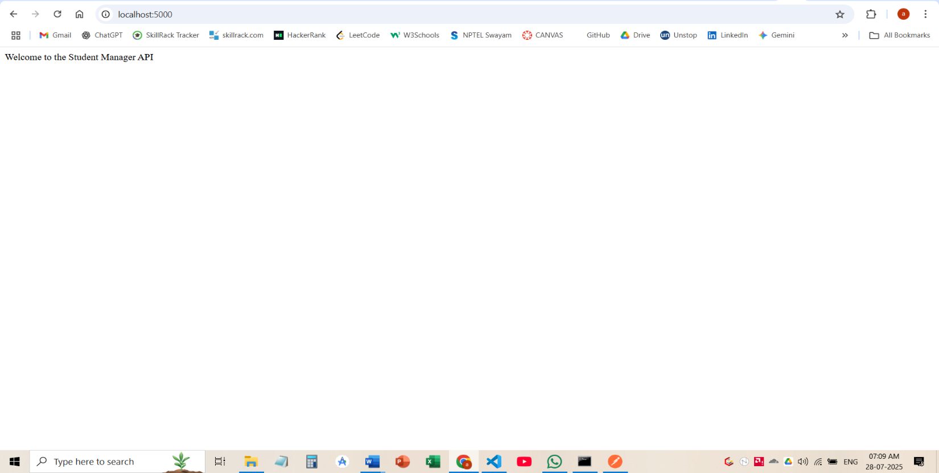
GET - http://localhost:5000/ - Test root
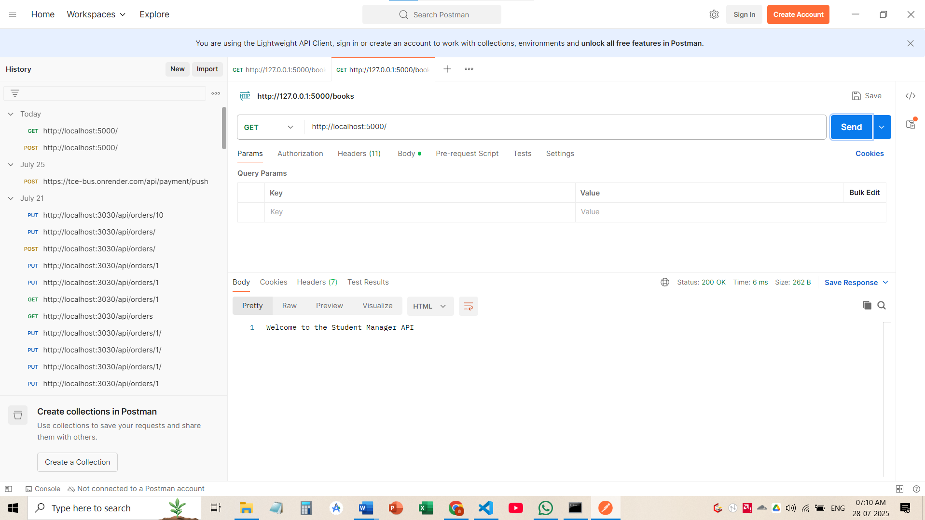

GET - http://localhost:5000/students - View all students
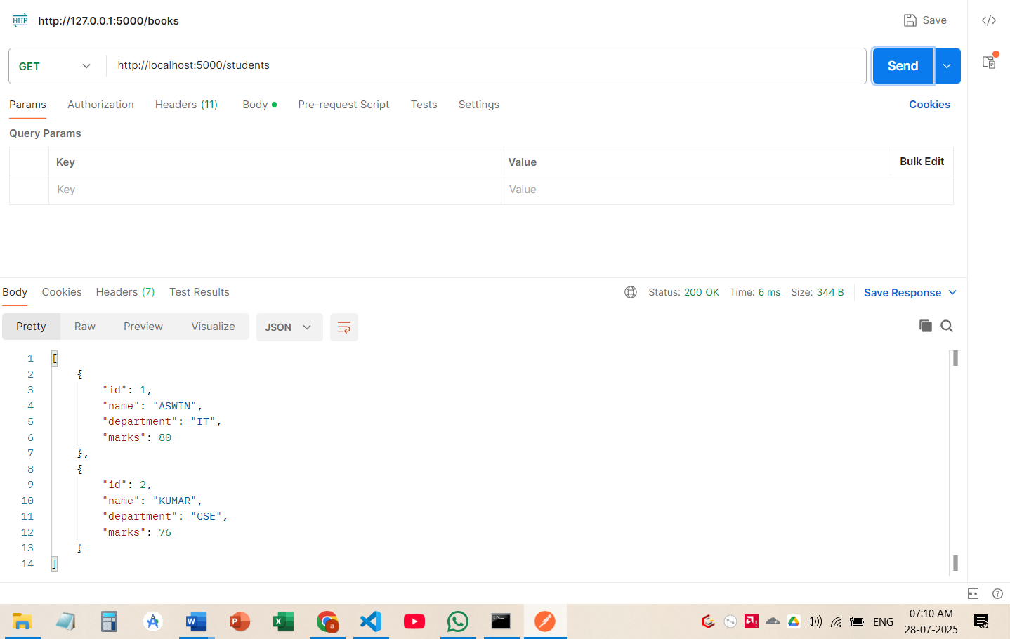
GET - http://localhost:5000/students/1 - Get student by ID
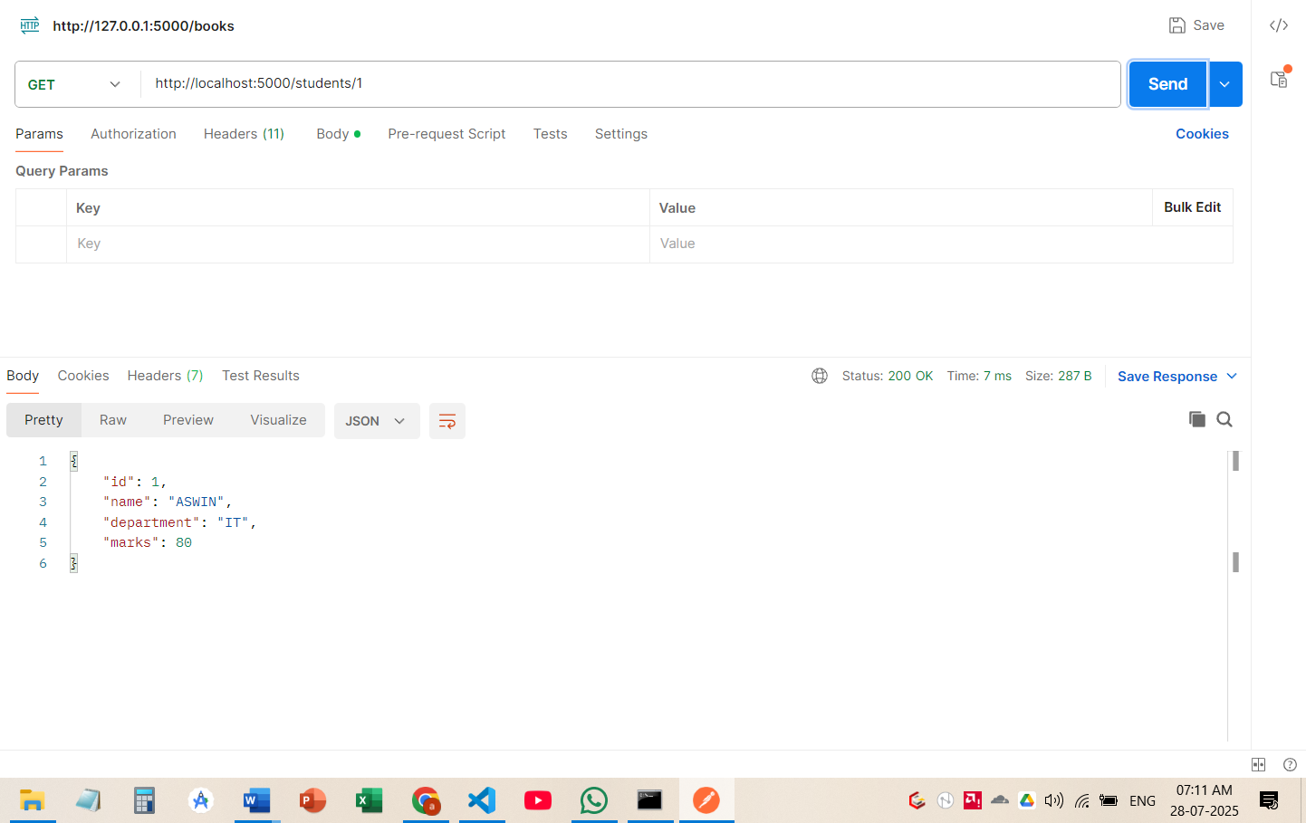
POST - http://localhost:5000/students - Add student
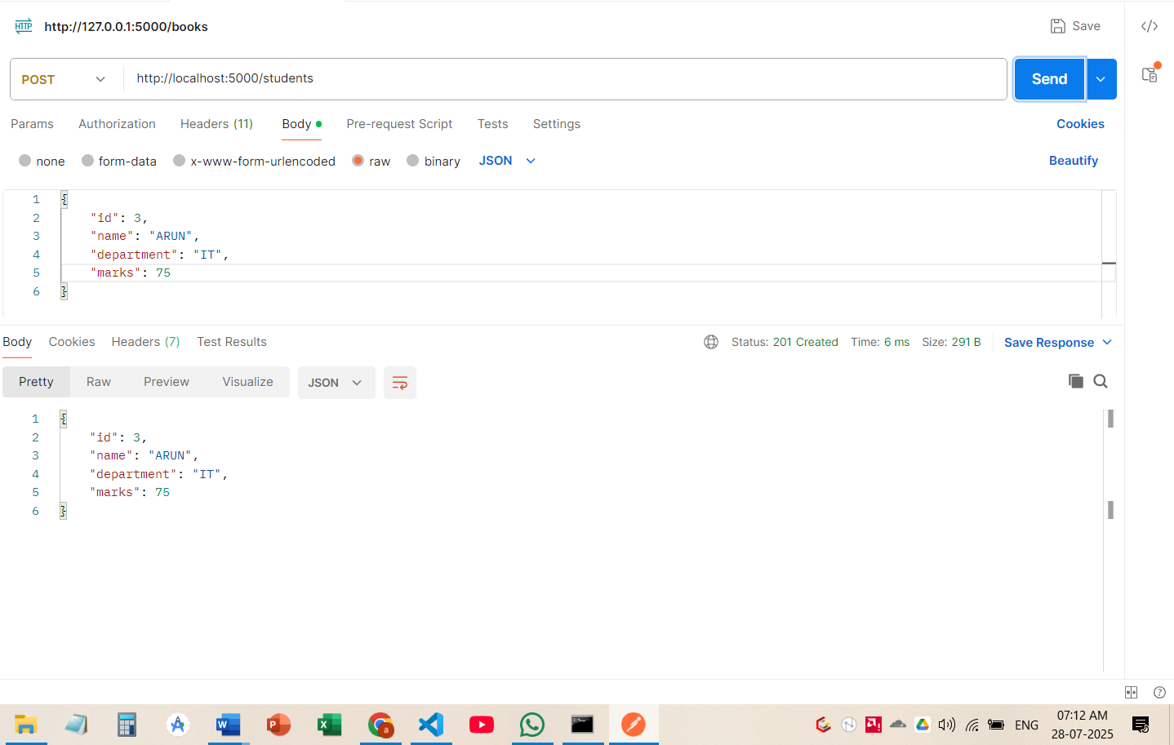
PUT - http://localhost:5000/students/3 - Update student
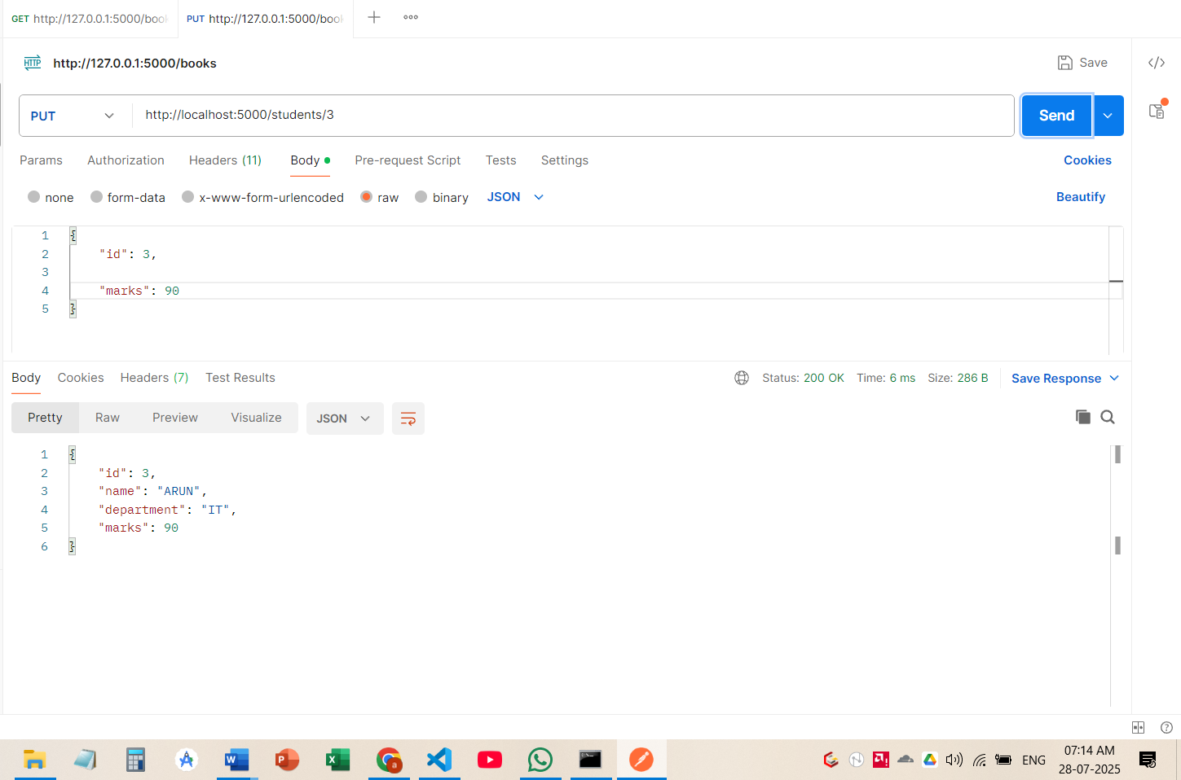
GET - http://localhost:5000/students - View all students
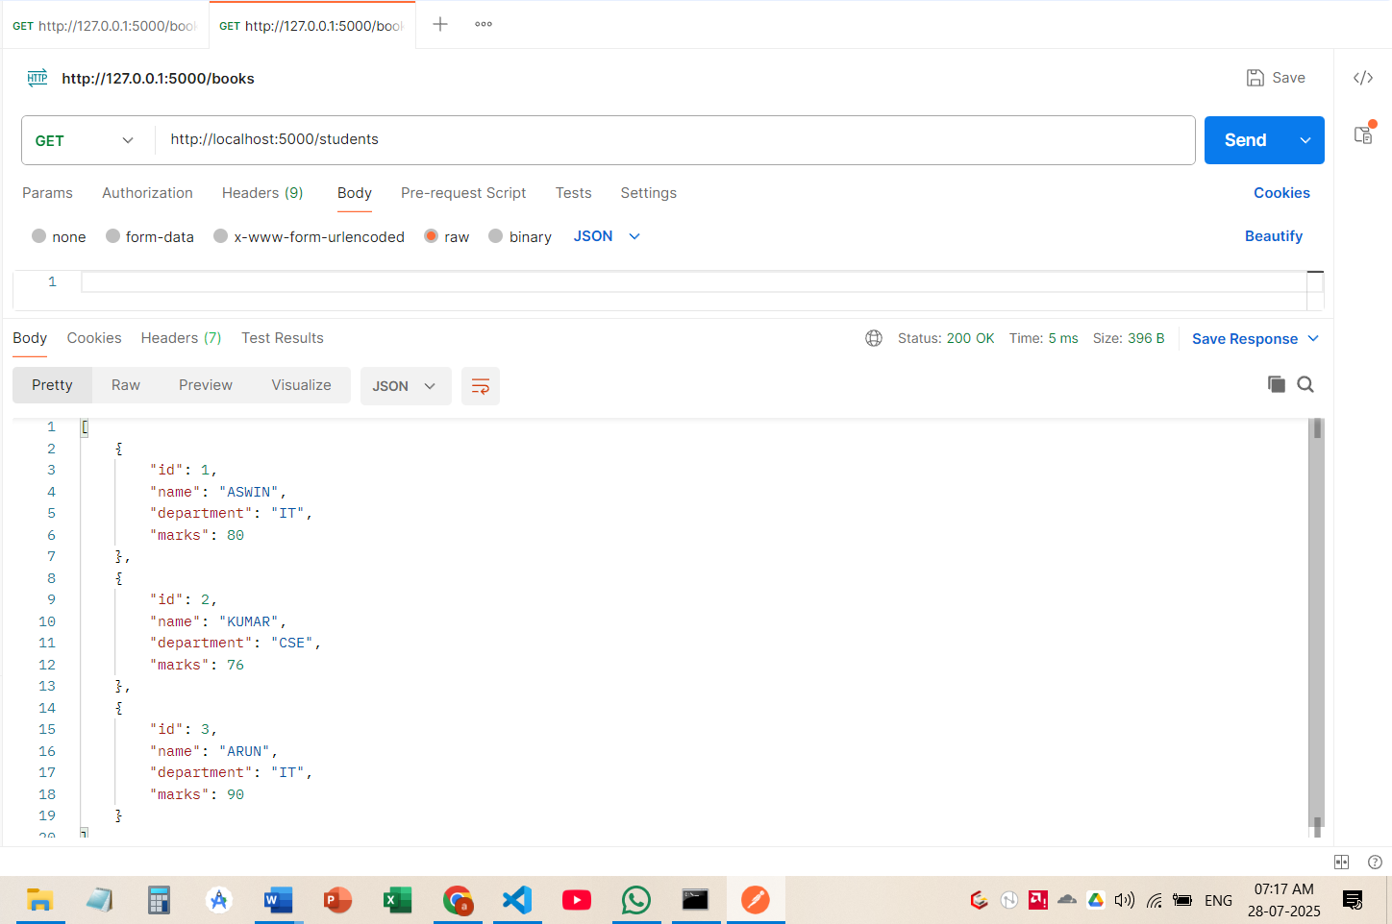
DELETE - http://localhost:5000/students/3 - Delete student
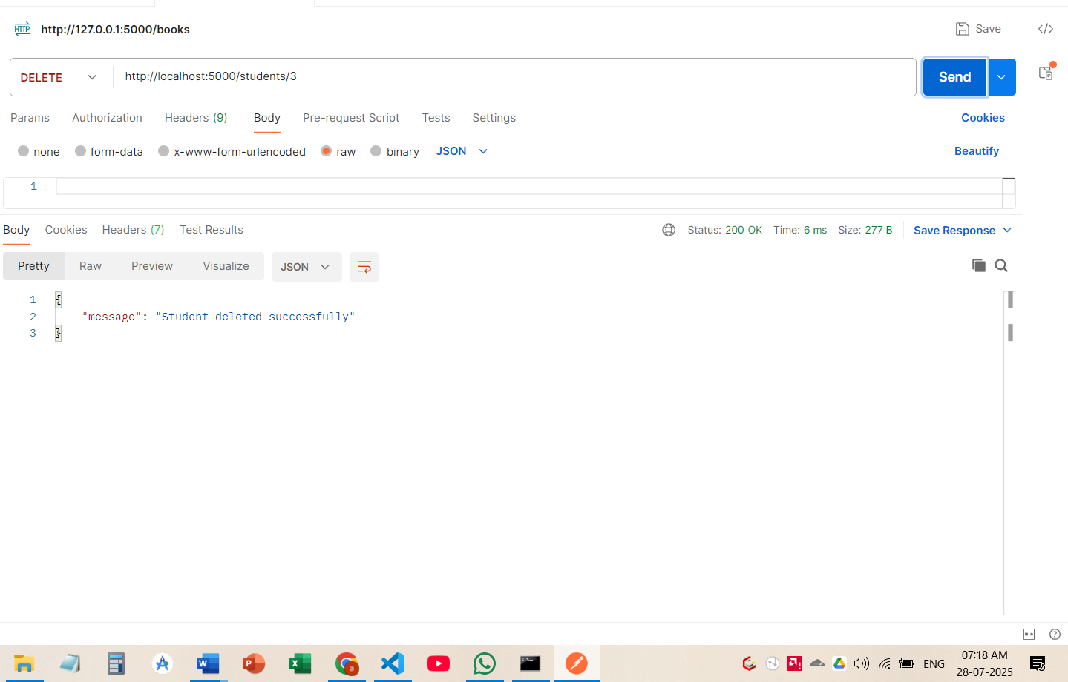
GET - http://localhost:5000/students - View all students
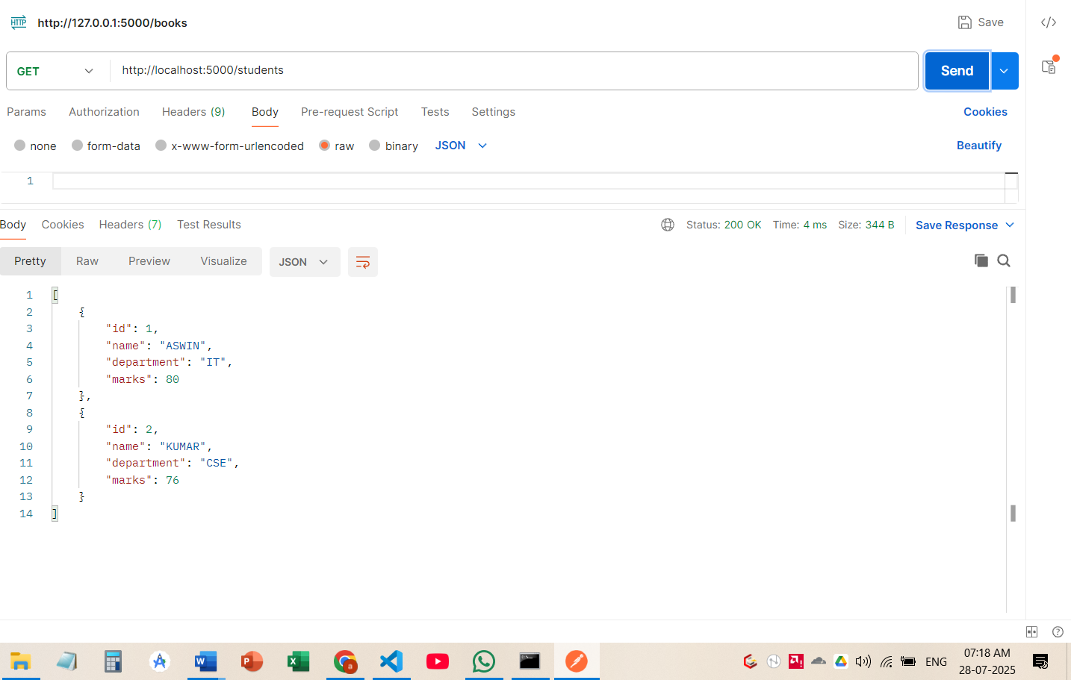
SOAP
- SOAP (Simple Object Access Protocol) is a protocol for exchanging structured information between systems over a network. It uses XML to format messages and is designed to be platform- and language-independent.
- Unlike REST (which is lightweight), SOAP follows strict standards and requires a WSDL (Web Services Description Language) file that describes the available services, their methods, and data structures.
- SOAP is most commonly used in enterprise-level applications like banking, finance, healthcare, telecom, and government systems, where security, reliability, and transactional integrity are critical.
Key Features of SOAP APIs
- Protocol-Based: SOAP is a protocol, not just a style. It follows strict rules.
- XML Messaging: All communication is done via XML (both requests and responses).
- Transport Independence: Works not only over HTTP but also SMTP, TCP, JMS, etc.
- WSDL Support: A WSDL document defines the structure, location, and methods of the web service.
- WS-Security: Provides built-in support for authentication, encryption, and integrity checks.
- Error Handling: Uses standardized SOAP Faults to report errors.
- Language & Platform Independent: Works across different systems. Supports ACID compliance .

Structure of a SOAP Message
A SOAP message is always an XML document containing the following elements:
<soap:Envelope xmlns:soap="http://schemas.xmlsoap.org/soap/envelope/">
<soap:Header>
<!-- Optional: authentication, transaction details -->
</soap:Header>
<soap:Body>
<!-- The actual request or response -->
</soap:Body>
</soap:Envelope>
- Envelope: Defines the start and end of the SOAP message.
- Header: Contains metadata (optional).
- Body: Contains request/response data.
- Fault (if error): Contains error messages.
Building a Simple SOAP API
Step 1: Create Project
mkdir soap-app
cd soap-app
npm init -y
npm install soap
Step 2: Create a SOAP Server (server.js)
const soap = require('soap');
const http = require('http');
const fs = require('fs');
const service = {
CalculatorService: {
CalculatorPort: {
Add: function(args) {
return { result: args.a + args.b };
},
Subtract: function(args) {
return { result: args.a - args.b };
}
}
}
};
const xml = fs.readFileSync('calculator.wsdl', 'utf8');
const server = http.createServer((req, res) => res.end("SOAP Service Running"));
server.listen(8000);
soap.listen(server, '/calculator', service, xml);
console.log("SOAP server running at http://localhost:8000/calculator?wsdl");
Step 3: WSDL File (calculator.wsdl)
<definitions xmlns="http://schemas.xmlsoap.org/wsdl/"
xmlns:soap="http://schemas.xmlsoap.org/wsdl/soap/"
xmlns:tns="http://example.com/calculator"
xmlns:xsd="http://www.w3.org/2001/XMLSchema"
targetNamespace="http://example.com/calculator">
<message name="AddRequest">
<part name="a" type="xsd:int"/>
<part name="b" type="xsd:int"/>
</message>
<message name="AddResponse">
<part name="result" type="xsd:int"/>
</message>
<message name="SubtractRequest">
<part name="a" type="xsd:int"/>
<part name="b" type="xsd:int"/>
</message>
<message name="SubtractResponse">
<part name="result" type="xsd:int"/>
</message>
<portType name="CalculatorPortType">
<operation name="Add">
<input message="tns:AddRequest"/>
<output message="tns:AddResponse"/>
</operation>
<operation name="Subtract">
<input message="tns:SubtractRequest"/>
<output message="tns:SubtractResponse"/>
</operation>
</portType>
</definitions>
Output
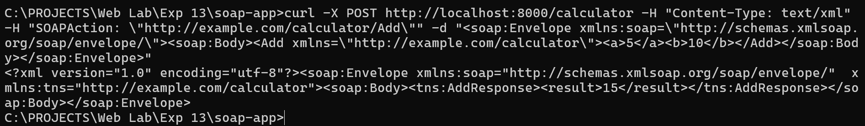

Result:
Thus, Web Services was practiced successfully.

